Teacher Notes for “Population Growth – Effects of the Environment"

In this analysis and discussion activity, students develop their understanding of the effects of environmental factors on population growth by analyzing the recovery of endangered species and how growth of bacterial populations can cause food poisoning. Students learn about the processes that result in exponential or logistic population growth, interpret data from several investigations, and apply their understanding to policy questions.

This learning activity will be suitable for most middle school students. A learning activity that will be suitable for most high school students is “Understanding and Predicting Changes in Population Size – Exponential and Logistic Mathematical Models vs. Complex Reality” (https://serendipstudio.org/exchange/bioactivities/pop).

Learning Goals
In accord with the Next Generation Science Standards:
- This activity will help students to meet these Performance Expectations:
- MS-LS2-1. “Analyze and interpret data to provide evidence for the effects of resource availability on organisms and populations of organisms in an ecosystem.”
- MS-LS2-4. “Construct an argument supported by empirical evidence that changes to physical or biological components of an ecosystem affect populations.”
- Students will gain understanding of two Disciplinary Core Ideas;
- LS2.A, Interdependent Relationships in Ecosystems: “Organisms, and populations of organisms, are dependent on their environmental interactions both with other living things and with nonliving factors. In any ecosystem, organisms and populations with similar requirements for food, water, oxygen, or other resources may compete with each other for limited resources, access to which consequently constrains their growth and reproduction. Growth of organisms and population increases are limited by access to resources.”
- LS2.C, Ecosystem Dynamics, Functioning and Resilience: “Ecosystems are dynamic in nature; the characteristics can vary over time. Disruptions to any physical or biological component of an ecosystem can lead to shifts in all its populations.”
- Students will engage in several Scientific Practices:
- Constructing Explanations. “Construct an explanation that includes qualitative or quantitative relationships between variables that predict phenomena.”
- Analyzing and Interpreting Data. “Analyze and interpret data to provide evidence for phenomena.”
- Using Models. “Develop a model to describe phenomena.”
- This activity provides the opportunity to discuss the Crosscutting Concepts:
- Cause and Effect: “Cause and effect relationships may be used to predict phenomena in natural or designed systems.”
- Stability and Change: “Explanations of stability and change in natural… systems can be constructed by examining the changes over time and forces at different scales…”

Instructional Suggestions and Background Information
To maximize student learning and participation, we recommend that you have your students work in pairs to answer each group of related questions. Student learning is increased when students discuss scientific concepts to develop answers to challenging questions. After pairs of students have worked together to answer a group of related questions, we recommend that you have a class discussion to probe student thinking and help students develop a sound understanding of the concepts and information covered.

A key is available upon request to Ingrid Waldron (iwaldron@upenn.edu). The following paragraphs provide instructional suggestions and additional background information – some for inclusion in your class discussions and some to provide you with relevant background that may be useful for your understanding and/or for responding to student questions.

This activity assumes students know what a species is. A species is generally defined as the largest group of organisms capable of interbreeding and producing fertile offspring. A learning activity and some information about the challenges of defining a species are available at https://serendipstudio.org/exchange/bioactivities/species.

Recovery of Endangered Species – Why does it take so long?
I recommend that you begin this section with a discussion of what your students already know about endangered species and the recovery of endangered species. What questions do they have?

I also recommend that you show the first 7 minutes of the video, “Whooping Cranes” at https://www.youtube.com/watch?v=ACUYXCLTvm8. If you show this video, it should increase student interest and serve as context for the information at https://journeynorth.org/tm/crane/jr/JnKidsOverview.html (recommended on page 1 of the Student Handout). For additional information about whooping cranes, see https://www.savingcranes.org/species-field-guide/whooping-crane/.

There were an estimated 10,000 or more whooping cranes in North America before European settlement. Due to hunting and habitat loss, the whooping crane population decreased to an estimated 500-1500 in 1870-1880, which further decreased to about 20 in the 1940s (https://en.wikipedia.org/wiki/Whooping_crane). Conservation efforts have allowed the one surviving population of wild whooping cranes to increase more than tenfold from the low point of ~20 wild whooping cranes in the 1940s (see graph on page 1 of the Student Handout). Recovery was slow initially because population growth was slower in the early stages when population size was small and because it took some time to fully develop and implement conservation efforts.

Questions about the recovery of endangered species will be discussed further at the end of this activity. In the intervening sections, students develop their understanding of exponential and logistic population growth by exploring bacterial population growth (which is easier to analyze than population growth for sexually reproducing, long-lived organisms).

Bacterial Population Growth and Food Poisoning
To introduce the section on bacterial population growth, you may want to show your students a 15-second video of bacteria dividing by binary fission; the video is available at https://www.youtube.com/watch?v=gEwzDydciWc and https://vimeo.com/14316782. It is important to note that this video has been speeded up by a factor of roughly 2000; typical doubling times for bacteria range from 20 minutes to several hours. You can slow this video down by a factor of four, so your students can more easily follow what is happening; turn off the sound, click on the settings icon in the lower right-hand corner, click on speed and then 0.25, and then play.

The bacterial population shows exponential population growth. The rate of increase in population size accelerates over time because the increase in population size in each time period is proportional to the size of the population at the beginning of the time period. As discussed in question 7, the population of whooping cranes (see page 1 of the Student Handout) shows approximately exponential growth for similar reasons.

Page 3 in the Student Handout relates bacterial population growth to a phenomenon some students may have experienced personally – food poisoning (also called foodborne illness). You may want to begin by asking students why they think that food poisoning has been included in a section on bacterial population growth; then, you could explore their previous knowledge and questions concerning food poisoning. It may be helpful to distinguish between the invisible bacteria that cause food poisoning and the visible layer of mold on some spoiled food. You may also want to mention that there are many types of bacteria, most of which do not cause food poisoning. Some types of bacteria are used in making foods such as yogurt or cheese. Other helpful bacteria live in and on our bodies in what is called the human microbiome (https://www.hsph.harvard.edu/nutritionsource/microbiome/).

Symptoms of Salmonella food poisoning include diarrhea, vomiting, abdominal pain and fever. Diarrhea and vomiting help to rid the body of Salmonella bacteria. From the point of view of the bacteria, diarrhea and vomiting have the benefit of helping to spread bacteria to potential new hosts. The Student Handout does not mention that diarrhea and/or vomiting can be due to causes other than salmonellosis, including other types of food poisoning (due to other types of bacteria or toxins produced by bacteria) or viral gastroenteritis (stomach flu); stomach flu can be transmitted via contact with someone who is infected, sharing eating utensils, or eating contaminated food.

Refrigeration is protective because Salmonella population growth is very slow at temperatures below 10ºC. Faster population growth of bacteria in contaminated food kept at room temperature increases the risk of food poisoning. Cooking also reduces the risk of food poisoning because cooking can kill bacteria that cause food poisoning; for example, most Salmonella bacteria are killed by heating contaminated food for 1-10 minutes at 60ºC or for less than 1 minute at 70ºC.

The delay between eating food contaminated with bacteria and first experiencing symptoms of food poisoning is due in part to transit time from the mouth to the intestines, but a major factor generally is the time it takes for the population of bacteria to multiply to the large population size needed to trigger symptoms. Salmonella bacteria multiply in the lumen and lining of the intestines.

Evidence that time is needed for population growth is provided by the observation that the delay is greater when fewer Salmonella have been consumed (see figure). The delay between exposure and first symptoms is often called the incubation period. This figure shows how incubation period (measured in hours) varies depending on the number of ingested Salmonella bacteria. Each data point represents a well-characterized episode of salmonellosis food poisoning. (Each episode affected between 26 and 967 individuals.) The ingested number of cells was estimated from the | 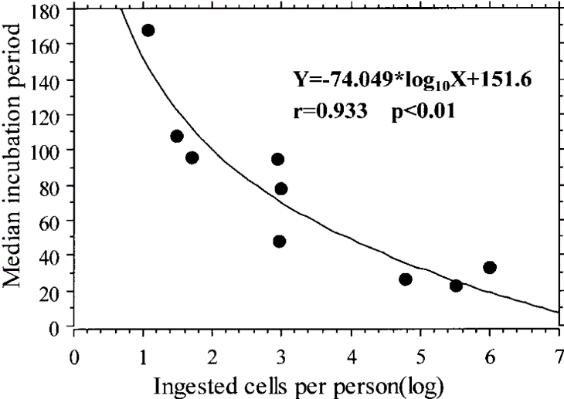  (Abe et al., Journal of Food Protection 67:2735, 2004)
concentration of Salmonella in a sample of the contaminated food and the amount of food eaten per person. The number of ingested Salmonella bacteria also influences the proportion of exposed individuals who develop symptoms of food poisoning. Susceptibility to food poisoning also depends on the effectiveness of the host’s defenses (e.g., people with AIDS, children under 12, and adults over 65 are more susceptible). General information about salmonellosis is available at https://en.wikipedia.org/wiki/Salmonellosis and
http://www.webmd.com/food-recipes/food-poisoning/tc/salmonellosis-topic-overview#1.

Brief introductions to food poisoning and practical advice to reduce the risk of food poisoning are available at https://www.choice.com.au/food-and-drink/food-warnings-and-safety/food-safety/articles/food-poisoning, https://www.cdc.gov/features/salmonella-food/index.html and https://www.nytimes.com/2018/05/28/well/how-to-minimize-the-risk-of-food-poisoning.html.

Questions 8-9 provide the opportunity for peer discussion and feedback on a topic likely to be of interest to the students. Question 10 provides a transition to the next section.

Limits on Exponential Population Growth
The exponential population growth model assumes unlimited resources to support exponential increases in population size. In contrast, the logistic population growth model includes the effects of competition for resources (e.g. food, water, nesting sites, or sunlight). Competition for resources is a density-dependent factor that increases as population size increases. It can result in increased mortality and/or decreased reproduction and thus slower population growth rate as population density increases.

You may want to point out to your students that the Y axis for the figure in question 11 has a logarithmic scale. The bacteria in this experiment contribute to food spoilage, not food poisoning. Students should be aware that food that is not obviously spoiled can cause food poisoning; food may be contaminated with specific types of bacteria that cause illness at doses well below what would be required to produce noticeable changes in appearance and smell that would be identified as spoiled food.

If you want to provide your students with an extension and challenge, you can use the following after question 11 in the Student Handout.

This graph shows how populations of these bacteria grew on pieces of tofu at different temperatures. This type of bacteria causes tofu to spoil or go bad. When population size reaches ~10⁶ bacteria per gram of tofu, the tofu has spoiled.  12. Use these data to explain why tofu that is kept at warmer temperatures will spoil more quickly. | 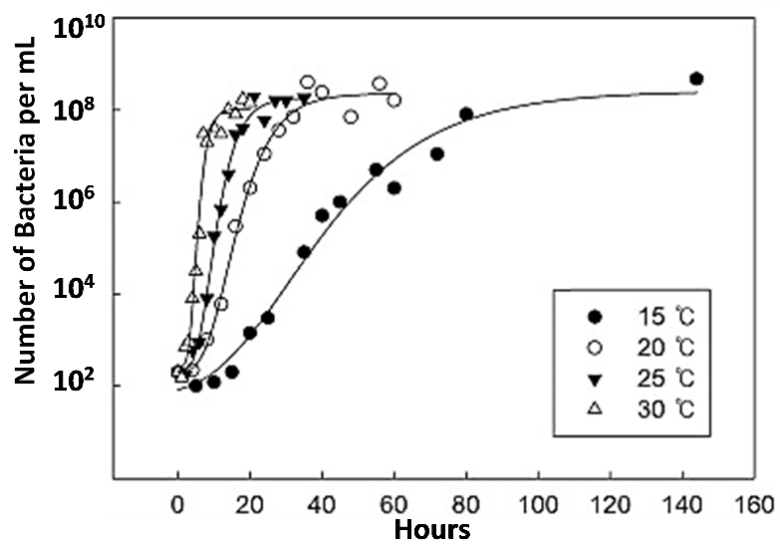

You may want to precede the explanation of the Paramecium experiment with this question.

13. How could you test whether competition for food or competition for space is the main limiting factor that determines the size of a population that an environment can support?

The Paramecium experiment described on page 4 of the Student Handout illustrates 1 possible way to test whether food or space is the limiting factor that determines carrying capacity for a population. The results shown above are for Paramecium aurelia which were grown in centrifuge tubes. Each day the Paramecia were centrifuged to the bottom of the tube, so the growth medium could be replaced with fresh medium that had the original concentration of bacteria as food for the Paramecia. The concentration of bacteria was twice as great for Population 2 as for Population 1. Although this experiment supports the conclusion that food was the main limiting factor for this population, it is | 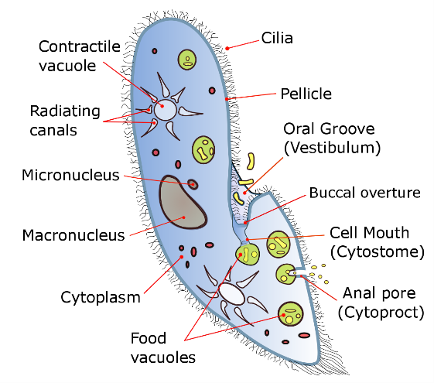  Paramecium
important to remember that in other situations population growth may be limited by other factors such as the accumulation of waste products or the availability of resources such as water, sunshine or nesting sites.

Carrying capacity means the maximum population that the environment can sustain over the long-term. This term is not used in this Student Handout, but it could be incorporated in question 13 by adding this clause to the end of the third sentence in this question:
“which is called the carrying capacity.”
Then, you can incorporate “carrying capacity” in subsequent paragraphs.

The Student Handout omits several complexities of bacterial population growth in laboratory experiments where the original food supply is not supplemented with additional food (see figure). At the beginning, there can be a “lag phase” when bacteria are adjusting to their new circumstances and producing molecules that contribute to exponential growth in the “log phase”. The “stationary phase” plateau corresponds to the stable population size at carrying capacity. If no new food is available, eventually the lack of food results | 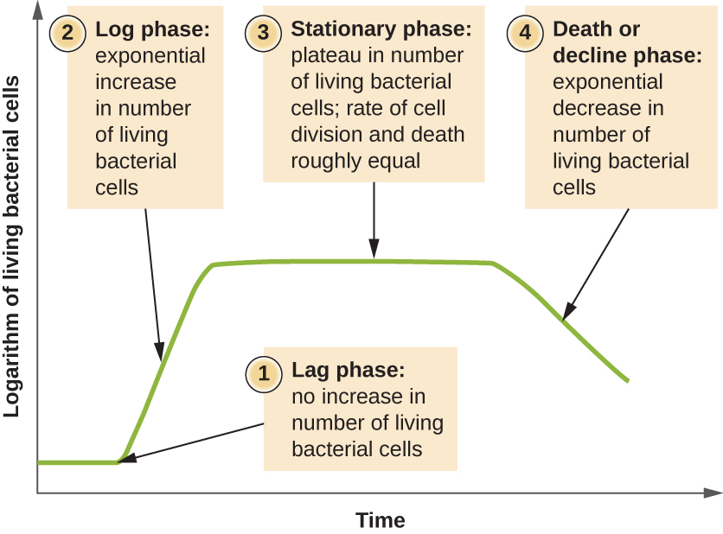  (https://courses.lumenlearning.com/microbiology/chapter/how-microbes-grow/ )
in the “death or decline phase”. A similar sequence of population growth and decline might be observed in nature for microorganisms growing in a dead plant or animal. In these situations, the definition of carrying capacity refers to the stationary phase. In many situations, where organisms are dependent on renewable resources (e.g. herbivores in a prairie), carrying capacity is the maximum population size that the environment can sustain indefinitely.

With respect to question 14, even for population A in the environment with abundant resources, exponential growth cannot go on forever; eventually, competition for resources will first slow and then stop population growth or an external environmental factor such as winter weather will limit population growth.

Questions 11-14 in the Student Handout provide a good opportunity to discuss the Crosscutting Concept, Stability and Change: “Explanations of stability and change in natural… systems can be constructed by examining the changes over time and forces at different scales…”

Using the Exponential and Logistic Population Growth Models to Understand Recovery of Endangered Species
A model is a representation of reality that highlights certain key aspects of a phenomenon and thus helps us to better understand and visualize the phenomenon. However, all models involve assumptions and simplifications of complex real-world phenomena, so there may be discrepancies between a model’s predictions and phenomena observed in the real world.

Many students tend to think of a model as a physical object and may not understand how a graph or equation can be a model. It may be helpful to introduce the idea of a conceptual model. As noted in A Framework for K-12 Science Education, “Conceptual models allow scientists… to better visualize and understand a phenomenon under investigation… Although they do not correspond exactly to the more complicated entity being modeled, they do bring certain features into focus while minimizing or obscuring others. Because all models contain approximations and assumptions that limit the range of validity of their application and the precision of their predictive power, it is important to recognize their limitations.” , To help your students understand conceptual models, you can give examples of conceptual models that students may have used, e.g. a map, a diagram of a football play, sheet music, a concept map, or an outline for an essay they plan to write.

At the beginning of this section, you may want to ask your students what they already know about endangered species and the recovery of endangered species. Question 15 focuses students on the errors that result when a person uses the wrong model to make predictions. Discussion of student answers to this question will also reinforce student understanding of the difference between linear and exponential population growth.

As discussed in question 16, additional populations in different locations would help to reduce the risk of extinction by providing additional habitat to support growth of whooping crane populations and by providing protection against a possible catastrophe in one location (e.g. due to a hurricane or infectious disease epidemic). In addition to the surviving population of whooping cranes discussed on page 1 of the Student Handout, conservation biologists have tried to establish additional populations of whooping cranes through a captive breeding program and careful training of the young whooping cranes to survive in the wild. To help your students understand how much effort went into trying to establish a second population, you may want to show “Flight to Survive: Saving Whooping Cranes”, a 4.5-minute video at https://www.youtube.com/watch?v=Ye4Swf3-yDM. In 2025, the result was nearly 70 wild whooping cranes, but these whooping cranes were scattered over several states, so reproduction has been low and not sufficient to maintain the number of whooping cranes.

The introduction to question 17 mentions habitat; you may need to define “habitat” for your students. Habitat is the natural environment where the organism lives. Question 17 could lead to a more general discussion of conservation biology.

Although this activity has focused on population growth, for many species of animals, the total number of individuals is decreasing. For example, “more than one-third of US bird species are of high or moderate conservation concern, including 112 Tipping Point species that have lost more than 50% of their populations in the last 50 years.” (https://www.audubon.org/press-room/us-bird-populations-continue-alarming-decline-new-report-finds). These decreases in total populations have been caused by habitat loss and other human-related harms. Conservation successes have been attributed to preservation of wetlands, limitations on hunting, banning DDT, etc. Suggestions for actions that middle schoolers might be able to take to prevent further decline in bird populations include:
- keeping cats indoors,
- growing native plants to make yards a better habitat for birds,
- making windows safer for birds by breaking up reflections of habitat that birds try to fly into (https://www.futurity.org/north-american-birds-habitat-conservation-3172242/).

This topic illustrates that evaluation of many public policy issues depend on both good scientific information and people’s values (which cannot be decided by science). For example, science can help us understand how fast endangered species can recover and science can show how different species have helped us to develop multiple helpful products (e.g. the many medications originally derived from plants, fungi or animals). However, science cannot establish how much value to assign to preserving endangered species like whooping cranes. Two useful general sources on endangered species are https://education.nationalgeographic.org/resource/endangered-species/ and https://www.nytimes.com/2018/03/13/magazine/should-some-species-be-allowed-to-die-out.html.

Related Activity
A possible additional or alternative activity is “Some Similarities between the Spread of Infectious Disease and Population Growth” (https://serendipstudio.org/exchange/waldron/infectious). This hands-on activity introduces students to some features of exponential and logistic population growth. First, students analyze a hypothetical example of exponential growth in the number of infected individuals. Then, a class simulation of the spread of an infectious disease shows a trend that approximates logistic growth. Next, students analyze examples of exponential and logistic population growth and learn about the biological processes that result in exponential or logistic population growth. Finally, students analyze how changes in the biotic or abiotic environment can affect population size; these examples illustrate the limitations of the exponential and logistic population growth models. This activity is aligned with the Next Generation Science Standards.

For additional related activities, see “Ecology Concepts and Learning Activities” (https://serendipstudio.org/exchange/bioactivities/ecology).

Sources for Figures and Data in Table
- Picture of whooping crane – http://www.audubon.org/field-guide/bird/whooping-crane
- Graph and table of trends in whooping crane population size – adapted from https://www.sciencedirect.com/science/article/pii/S0006320713000980, Figure 1 and Table 1, plus https://www.fws.gov/uploadedFiles/Region_2/NWRS/Zone_1/Aransas-Matagorda_Island_Complex/Aransas/Sections/What_We_Do/Science/Whooping_Crane_Updates_2013/WHCR_Update_Winter_2016-2017.pdf
- Food poisoning figure – based on https://static.shakethatweight.co.uk/uploads/filter-porridge-1.svg, https://i.pinimg.com/originals/d5/7c/f9/d57cf9fa76b9a87c5a9157cbc8c3a6a9.jpg, and https://www.jagranjosh.com/imported/images/E/Articles/Diseases-caused-by-food-poisoning.png
- Graph of logistic population growth for bacteria – adapted from https://ars.els-cdn.com/content/image/1-s2.0-S002364381630768X-gr1.jpg
- Graph of logistic population growth for Paramecia – based on data from “The Struggle for Existence”, by G. F. Gause, 1934
- Exponential and logistic population growth – adapted from https://www.researchgate.net/figure/Comparison-of-exponential-and-logistic-growth_fig4_222499741
- Graph of Jim’s predictions, created by the author

By Dr. Ingrid Waldron, Biology Department, University of Pennsylvania, 2025. These Teacher Notes and the related Student Handout are available at https://serendipstudio.org/exchange/bioactivities/popgr.
Quotations from https://nextgenscience.org/sites/default/files/MS%20LS%20DCI%20combinedf.pdf and https://www.nextgenscience.org/.
Since 2015 the US Fish and Wildlife Service has used better methods to estimate the winter population of whooping cranes in Texas, resulting in substantially higher estimates of population size, including the estimate of ~560 in 2025 (https://iris.fws.gov/APPS/ServCat/DownloadFile/155390; https://iris.fws.gov/APPS/ServCat/DownloadFile/274487). The graph and table on page 1 of the Student Handout show data obtained using the old methods, which were consistent over time.
One reason that recovery was slow is that a pair of mated whooping cranes has only about one chick per year.
For more capable students, you can eliminate the number labels for the axes for the graph in question 5 and have the students label the axes.
It should be mentioned that some strains of Salmonella enterica cause typhoid fever, which is much more serious than the type of food poisoning discussed in this activity. If untreated, typhoid fever results in 10-20% mortality; for treated patients, mortality is less than 1%.
An example of density-dependent effects on reproduction was observed after deer hunting was permitted in one area of the Adirondacks; the number of deer decreased, the availability of food increased, and the percent of female deer which were pregnant and the number of embryos per female increased dramatically.
The diagram is from https://upload.wikimedia.org/wikipedia/commons/f/f7/Paramecium_diagram.png.
Quotation from A Framework for K-12 Science Education: Practices, Crosscutting Concepts, and Core Ideas (available at http://www.nap.edu/catalog.php?record_id=13165).
This point is developed in the more complete activity, "Understanding and Predicting Changes in Population Size – Exponential and Logistic Mathematical Models vs. Complex Reality" (https://serendipstudio.org/exchange/bioactivities/pop).

